 | Our Lady of Lourdes - Parish & Diocesan Shrine  Our Lady of Lourdes Presbytery, Uxbridge St., Hednesford. WS12 1DB  01543 422576 / olol.hednesford@rcaob.org.uk  Parish Priest Father Jeremy Howard 07868 542268 fr.jeremy.howard@rcaob.org.uk  Parish Deacon Reverend Peter Tibke  Parish Secretary Mrs Anne Walker  Parish Safeguarding Rep –  Befriending Group – Mick Jobburns 07789 111767  Website ololhednesford.org Facebook Our Lady of Lourdes Hednesford  WhatsApp Group – text 07868 542268 | 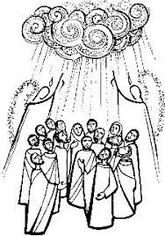  The Ascension
The Office is open Monday & Wednesday 9 am – 1 pm. Fr Jeremy is not normally available on Tuesdays.

Sunday 5 May 2024 – Sixth Sunday of Easter - Day of Prayer for Eastern Christians
On this day we pray for peace in the world, especially in the Middle East, that the Christians in these lands may be strengthened in their faith so that they may continue steadfastly to give witness to Jesus Christ.

Second Collection for Church Maintenance

Our Lady’s Lamp – Dennis & Marie Murray RIP
Coffee Morning in the Hall after mass

Masses

School Masses at 2.30 pm in the School Hall followed by refreshments.
May 9th - Ascension, May 16th - Mary, June 20th - Sacred Heart & July 11th - Leavers

Midweek Masses

From this week all Midweek Masses will be in the Sacred Heart Chapel in church apart from the 11.30 Mass in the Hall on Wednesdays in term time. Adoration from 9 - 9.25 am before 9.30 am Masses.

Masses this week,

- Monday - Mass at 10 am with no Adoration as this is a Bank Holiday.
- Thursday is the Feast of the Ascension of the Lord, a Holy Day of Obligation. Masses at 2.30 pm in St Joseph’s School (all welcome) and at 6.30 pm in Cannock.

Sat | 4 May | 6 pm | Vigil - Easter 6 | RIP Larry & Elizabeth Winwood
Sun | 5 May | 9.15 am | Easter 6 | RIP Daisy Woollaston
Mon | 6 May | 10 am |  | Ints Sr Jean Searson
Wed | 8 May | 11.30 am |  | Parish & People - In the Hall
Thu | 9 May | 2.30 pm | Feast of the Ascension | Ints Sr Dympna Smith - In St Joseph’s School
Thu | 9 May | 6.30 pm | Feast of the Ascension | In St Mary’s Cannock
Fri | 10 May | 9.30 am | St John of Avila | Ints Sr Alice Simm
Sat | 11 May | 6 pm | Vigil - Easter 7 | Agnes & John Grady Golden Wdg
Sun | 12 May | 9.15 am | Easter 7 | Srs of Charity of St Paul

Songbirds in Harmony  Summer Concert  At 7.30 pm on Saturday 15 June in the Hall. Tickets £10. The raffle & refreshments will be for church funds. Contact Anne Walker for more information. | Congratulations to Mgr Timothy Menezes  We are very pleased that Mgr Timothy Menezes, a good friend to our pilgrimage and parish for some years, has been appointed as one of two new Auxiliary Bishops for the Archdiocese. There is a card at the back of church to sign to pass on our best wishes and prayers.  Bingo Night Thanks.  Thanks to Mick Jobburns and his team for raising £197 at the Bingo Night on Friday April 26th.

Join Mary’s Meals in prayer during May
Mary’s Meals is now providing life-changing school meals to more than 2.4 million of the world’s poorest children. Their work is built on the power of prayer, and as a result they continually see God's love and provision in incredible ways During the month of May, dedicated to Our Lady, we are invited to join them in praying for the hungry children who rely on their life-changing school meals, and for all the children and families around the world who live in poverty. To access prayer resources go to
https://www.birminghamdiocese.org.uk/news/pray-in-may-with-marys-meals

Financial Matters
28/4/2024 Standing Orders £121.50. Gift Aid £80, other £95. Second Collection – CAFOD Sudan Appeal £94. 2nd Collections: 5 May Church Maintenance, 12 May Catholic Communications. Foodbank - 85 Kilos collected in both parishes, 200 Club – April winner No 12 Elizabeth Kolawole, May subs now due. Online donations at https://donate.mydona.com/our-lady-of-lourdes-hednesford.

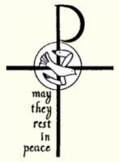 | 7/5 Samuel Lantry 1986, Barbara Smyczek 1996, Jean Jones 2005, Olga Medawar 2010  10/5 Alice Kilgallon 1976, Maggie Wright 1998, Joan Jones 2020  11/5 Mary Bohills 1948, John Brice 1982

Salvatore Guarneri, Joan O’Sullivan, John Dewhurst, Anna Moorcroft, Margaret Phipps, Tom Poxon, Zorah McQuillan, Florence Craddock, John Martin, Den Owens, Helen Dale, Peer Mohammed, Sue Atkinson, Jane Seal, Sue Titley, Peter Woollaston, Margaret Wilkinson, Sue Green, James Hunt, Phyllis Michael, Bert Dodd, Míchael Liddy, Margaret Brown, Sylvia Hale, Henry & Josephine Kafwembe, Janet Barker, Mary Klek, Jack Kennedy, Jane Goodyear, Maureen Dewhurst, Mark Duffy, Christopher Allan, Dominic Mulchrone, Clare Murphy, Tess Dudley, Jean Bird, Sophie King, Oscar Wordsworth, Matt Twohig, Anne Conway-Jones, Peter Hawthorne, Kath Poole, Roy Cashmore, Christine Makinson, Michael M, Ivan Molyneaux, Russell Mackuin, Pauline March, Richard Sharp, Alan White, Margaret Reynolds. | 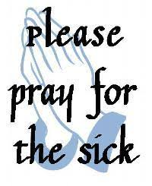

Reflection on Marriage following the Diocesan Mass for Marriage

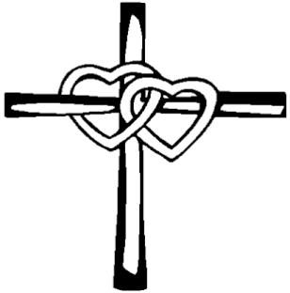

At Holy Mass we commemorated the English Martyrs, with readings on the Stoning of St Stephen and the coming persecution of the saints. While at first glance these readings did not seem to have much to say to us about marriage, a deeper reading reveals the kind of love that is necessary for couples to maintain a relationship that will face many struggles and oppositions: that of sacrificial love.

We see this love in the first Covenant God made with His people, Israel, but it is especially apparent in the New Covenant. Through Christ’s Life, Death and Resurrection, God has solemnly bound Himself to His Church, with the promise that He will never forsake us. And His love is not dependant on ‘terms & conditions!’ God’s Covenant in Jesus Christ – which is offered totally and irrevocably – acknowledges our great dignity as people created in His image.

Setting out his vision for Christian marriage, St Paul writes to the Ephesians: “Husbands, love your wives, as Christ loved the church.” (Eph 5:25) And how did Christ love the Church? Paul adds immediately: by giving Himself up for her. The language of sacrifice and covenant is exactly fitting for this union between a man and a woman, who seek to embody the love of God in this Sacrament. Sadly, we don’t live up to this high standard in so many areas of our lives, and marriage is no exception.

A question for us all, in whatever Vocation we have been called to is: how will we respond to the sacrificial love of God which is offered for our salvation – and how will that influence the way we show love to others?

Paul Northam, Diocesan Advisor for Evangelisation & Discipleship (with Marriage & Family Life)

